Chemistry of nano-materials

- Introduction to nanomaterials
- Comparison between bulk and nano particles.
- Synthesis methods: -
- Solution combustion
- Hydrothermal
- Characterization techniques
- Disadvantages (Toxicity) of Nanomaterials
- Applications of nanomaterials in various fields.
Introduction:
Nanomaterials are corner stones of nanoscience and nanotechnology. Nanostructure science and technology is a broad and interdisciplinary area of research and development activity that has been growing explosively worldwide in the past few years. It has the potential for revolutionizing the ways in which materials and products are created and the range and nature of functionalities that can be accessed. It is already having a significant commercial impact, which will assuredly increase in the future.
Nanoscience: The study of phenomena and materials at the atomic, molecular and macromolecular scales, where properties differ significantly from those at the larger scale
Nanotechnology: Design, characterization, production and application of structures, devices and systems by controlling morphology (size, shape and distribution) at the nano-scale.
Q What are nanomaterials?
Nanoscale materials are defined as a set of substances where at least one dimension is less than approximately 100 nanometers. A nanometer is one millionth of a millimeter - approximately 100,000 times smaller than the diameter of a human hair. Nanomaterials are of interest because at this scale unique optical, magnetic, electrical, and other properties emerge. These emergent properties have the potential for great impacts in electronics, medicine, and other fields.
Comparison between bulk and nano particles.
Properties vary with size are:- (i) Surface area (ii) Electrical property (iii) Optical property (iv) Catalytic property (v) Magnetic property, Etc
- Materials in the micrometer scale exhibit physical properties almost same as that of bulk form. However, materials in the nanometer scale exhibit physical properties distinctively different from the bulk. Properties of any bulk material are independent of its size. Properties of a bulk material can be altered only by altering their structure and composition. For example: - melting point of gold remains same whether the size of gold is 1 gram or 1 kg. A piece of gold is golden in color however big or small it is. But in nanoscale range, a material with same structure and composition will show different properties when the size of material is slightly varied
- Bulk gold melts at 1064 °C, but particles in the 5 nm size range melts at about 830 °C.
- Electronic band of a crystal is gradually quantized as the size is reduced, resulting in an increase in the band-gap energy.
- Cobalt normally has a hexagonal lattice arrangement, but this is transformed to FCC for cobalt particles smaller than 20 nm.
- A colloid of gold nanoparticles is no longer “golden” but ruby red /colorless in colour. Only the materials in the nano size range exhibit these size dependent properties, because a transaction from atoms or molecules to bulk form takes place in this size range. Nano materials exhibit several size dependent properties.
Q How nanomaterials are synthesized?
Nanomaterials are made by two generalized processes
- Top down: Start with the big chunk and cut away material to make what you want. It begins with bulk materials that are subsequently reduced into nanomaterials.
Ex: Inert gas condensation, Ion beam technique, Laser ablation, etc

Bottom -up Top down
- Bottom -up: Building what you want by assembling it from small prefabricated units molecules react under chemical or physical circumstances to form nanomaterials. such as atoms and molecules. It begins with atoms and molecules/. These atoms or
Ex: Hydrothermal, Sol-gel method, Co-precipitation and Combustion synthesis

Q. What is solution combustion synthesis? Mention the advantages of this method. Explain synthesis of nano ZnO particles using solution combustion method.

Solution combustion process is a self-propagating high temperature synthesis in which exothermic reaction takes place accompanied by the evolution of gases

Oxidizer (O) metal nitrate
Distilled water
O/F=1

Combustion
(Flame-temperature 900-1200 °C)
Nanocrystalline powder of metal oxide
Aqueous redox mixture in preheated muffle furnace (~400 °C)
Fuel (F)

Dehydration

Flow – Chart for synthesis of nano particles by solution combustion method

It is another wet-chemical method like sol-gel and hydrothermal, which has been proved to be an excellent technique for preparing several grams micro/nanocrystalline materials due to its short processing time, low processing temperature. This technique is based on exothermic redox reactions that undergo self-sustaining combustion. Mixtures of oxidizer (usually metal nitrates) and a fuel (organic compound containing carbon and hydrogen; e.g. urea, citric acid or glycine as fuel) undergo spontaneous combustion under heating and the chemical energy from the exothermic reaction heats the precursor mixture to high temperatures. Such a high temperature leads to formation and crystallization of nano materials.).
Advantages of solution combustion method:
Among wet chemical routes, the low temperature solution combustion process is an attractive one and finds several advantages like-
- The synthesis temperature (300 ^{O}C) employed is lower than those currently used in conventional route.
- Simple and energetically attractive process.
- Ability to dope desired amounts of impurity ions with better homogeneity.
- The powders are voluminous, foamy, sinteractive and in nanoscale having large surface area.
- Short reaction time (few seconds to 5 minutes)
- Chemical homogeneity

Example: Synthesis of ZnO nano particles by solution combustion method: Refer lab manual, page -28
Q. Explain synthesis of nano particles using hydrothermal method
It is a solution based method to prepare wide range of nanomaterials having diverse shapes and size. It is a method to produce different chemical compounds and materials using closed-system in aqueous solutions at temperatures above 100°C and pressures above 1 atm.
Principle: It is based on the principal of dissolution and recrystallizing substances from high temperature aqueous solutions at high vapour pressure. The crystal growth is performed in an apparatus consisting of a steel pressure vessel called autoclave, in which a nutrient (precursors) is supplied along with water. A gradient of temperature is maintained at the opposite ends of the growth chamber so that the hotter end dissolves the nutrient and the cooler end causes end causes seeds to take additional growth.
Procedure: In typical hydrothermal synthesis, stoichiometric amount of precursors and ~20-25 ml of double distilled water is taken in a Teflon liner. In few cases to maintain the basic pH alkali like NaOH or KOH are also added. Then the mixture are stirred well using magnetic stirrer to ensure complete homogenous mixing, until all the contents are evenly distributed. Later, the Teflon liner is kept inside the autoclave and sealed firmly. The complete autoclave assembly is then kept in a Hot air oven at a desired temperature (generally < 150 ^{O}C) and reaction is carried for desired time (Depending on material time varies between 2 and 24 h). Then, after the reaction, the product is washed with water and ethanol to remove impurities and the products are dried at 60 ^{O}C for 3 h in a dust proof hot air oven to get nanocrystalline materials.
For example: Preparation of BiFeO₄ by hydrothermal - Equimolar mixtures of bismuth nitrate (Bi(NO₃)₃.5H₂O) and iron nitrate (Fe(NO₃)₃.9H₂O) are dissolved in distilled water. Add 8 M sodium hydroxide (NaOH) and stir for 30 min and poured into an autoclave. The hydrothermal treatment is conducted at 180 ºC for 12 h. The produced powder is collected at the bottom of the autoclave after cooling to room temperature. The product is washed several times by repeated cycles of centrifugation in distilled water and ethanol. The obtained powder is heated at 80 ºC for 1 hr.

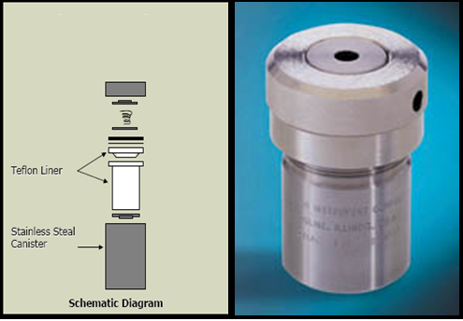

Q What are the advantages and disadvantages of hydrothermal method?
Advantages:
- High efficient and low-cost production of advanced materials
- Crystalline, single and multi-component oxide materials
- Environmentally safe and simple process, since water is used
- It involves H₂O both as a catalyst and component of solid phases at elevated temperature (> 150 °C) and pressure (> a few atmosphere).
- It is the suitable method for the growth of large good-quality crystals while maintaining good control over their composition.
- Inorganic nanomaterials that cannot be prepared by other wet chemical methods can be prepared by hydrothermal methods. Eg: Zns , Y₂O₂S, YF₃ etc.
- A good control over the morphology and size of the nanomaterials can be achieved by hydrothermal method.
Disadvantages:
- Large quantity of product can’t be obtained i.e the yield is less.
- High reaction time.
- Un safety method – working with high pressure autoclaves

Q - Mention the various techniques used in characterization of nano powder sample
The various characterization techniques used are – (i) Powder X-ray diffraction (ii) Scanning electron microscopy (SEM) (iii) Transmission electron microscopy (TEM)
Additional information about the techniques (Not required for exam)
(i) Powder X-ray diffraction: X-rays are passed through a crystalline material and the pattern produced and gives information on phase purity and crystallite size of the product. X-ray beam diffracted from a lattice plane can be detected when the X-ray source, the sample and the detector are correctly oriented to give Bragg diffraction. If X-ray beams strikes nano powder sample, they will pass directly through the sample and diffracted beams are collected by a detector and X-ray diffraction pattern is obtained.
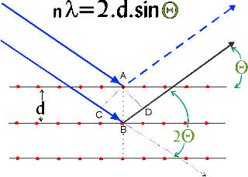
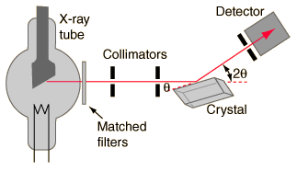
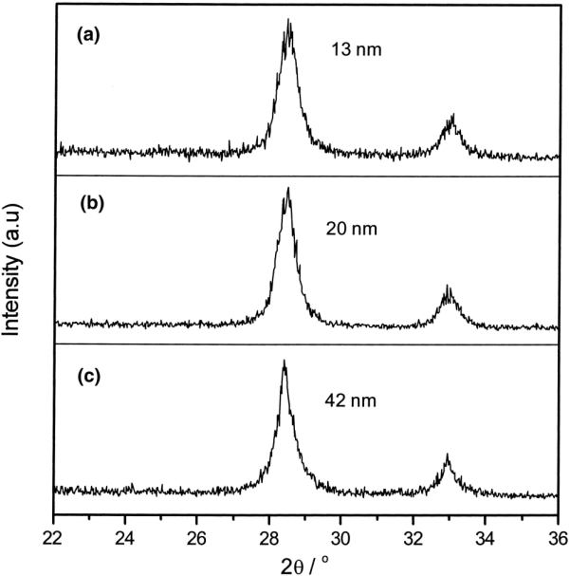
Fig: The crystallite sizes of nano powders determined by Scherrer’s formula
The average crystallite size (D) of nano materials can be estimated from the line broadening in X-ray powder ie., the full width at half-maximum (FWHM) of the diffraction peak of the powders using Scherrer’s formula. D = K λ /β cosθ
where β is full width at half maxima (FWHM) of XRD peaks, λ is the wavelength of X-ray and θ is the Bragg angle, K is a constant (shape factor, it is taken as 0.9 for circular particles)
Additional information about the techniques (Not required for exam)
(ii) Scanning Electron Microscopy (SEM)
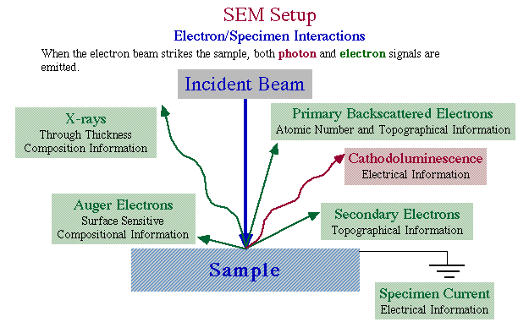
Surface morphology (Size, shape and distribution of nano-materials) is analyzed by SEM. Generally, it gives the size of the particles in agglomerated state. The SEM is a type of electron microscope and produces a largely magnified image of the nano powders by using electrons instead of light. Electrons have both particle and wave-like properties. When accelerated through a voltage, electrons can have a wavelength on the order of 0.1 nanometers. A beam of electrons is produced at the top of the microscope by an electron gun. The electron beam follows a vertical path through the microscope, which is held within a vacuum. The beam travels through electromagnetic fields and lenses, which focus the beam down towards the sample and produces various types of electrons including back scattered electrons. When these secondary back scattered electrons reach the detectors they convert them into a signal and sent to the computer screen as final SEM images

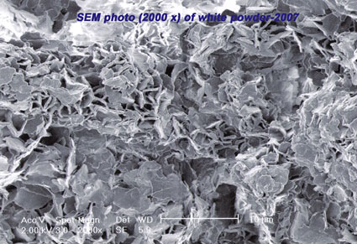

Fig : (a) Interaction of electron beam with the sample in SEM
(b) SEM micrograph

Additional information about the techniques (Not required for exam)
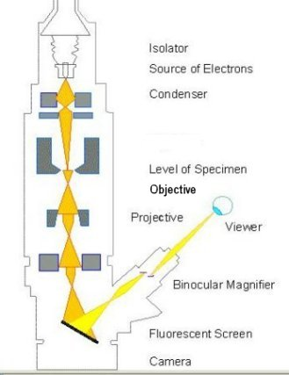
(iii) Transmission electron microscopy (TEM)
TEM is another type of high resolution electron microscope, it gives the size of the particles more accurately than SEM, it is an unique tool in characterization of materials microstructure by diffraction and imaging techniques. In this instrument a beam of electrons is focused onto a specimen causing an enlarged version to appear on a fluorescent screen or CCD camera. The source of the electrons in TEM is thermionic discharge and the electrons produced are accelerated using electric field and controlled by electric, magnetic fields onto the sample. The advantage of this electron microscopic technique over SEM is that TEM shows
much very high resolution image.

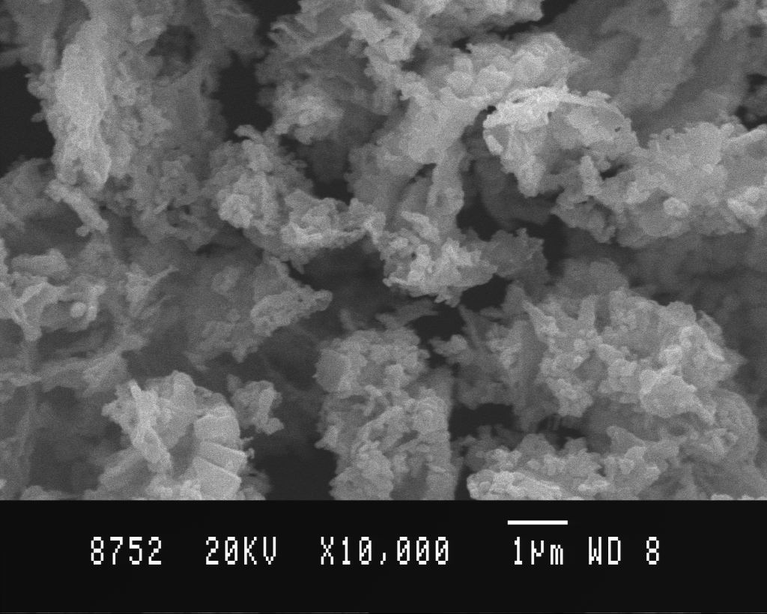
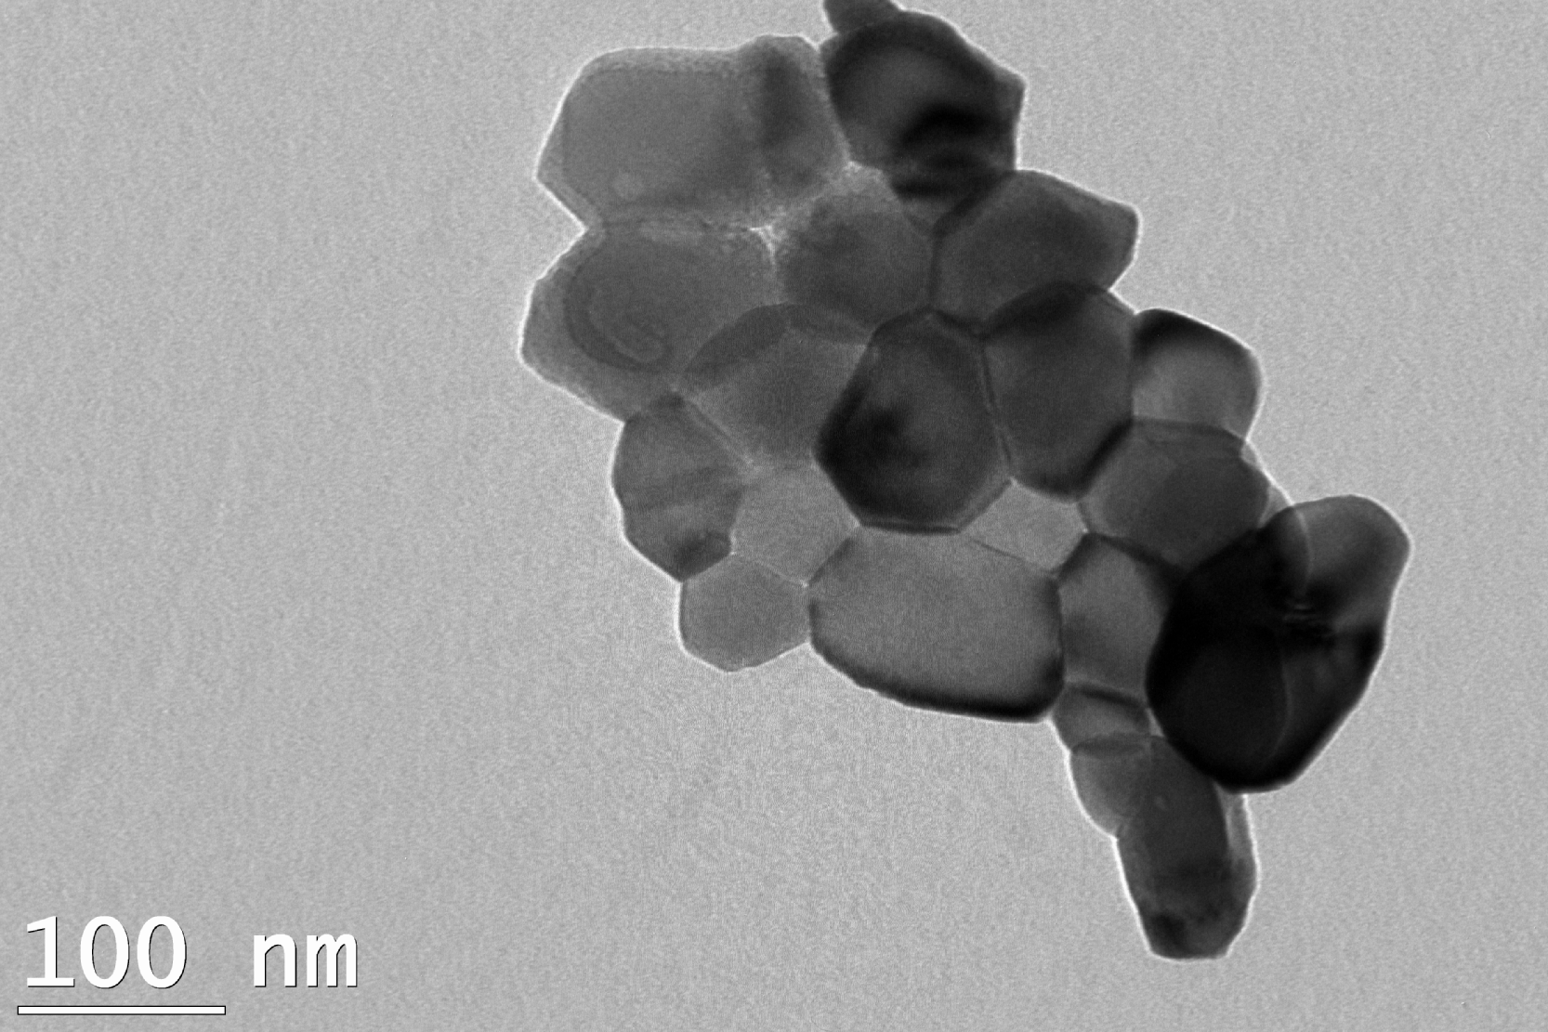

SEM TEM
Figs. Comparison of SEM and TEM micrographs of Zno nanoparticles

Disadvantages (Toxic effect) of Nanomaterials

Nanomaterials | Possible Risks
Carbon nanomaterials, silica nanoparticle | Pulmonary inflammation, granulomas, and fibrosis
Carbon, silver and gold nanomaterials | Distribution into other organs including the central nervous system
Quantum dots, carbon and TiO₂ nanoparticles | Skin penetration
MnO₂, TiO₂, and carbon nanoparticles | May enter brain through nasal epithelium olfactory neurons
TiO₂, Al₂O₃, carbon black, Co, and Ni nanoparticles | May be more toxic than micron sized particles

- Toxic effect of Size – Nano particles of any material have a much greater surface to volume ratio (i.e. the surface area compared to the volume) than larger particles of that same material). They are more toxic than larger particles and able to cross cell membranes, reach the blood and various organs and effect the parts.
- Toxic effect of Chemical composition– The toxicity of nanoparticles depends on their chemical composition, and amount absorbed onto their surfaces. However, the surfaces of nanoparticles can be modified to make them less harmful to health.
- Toxic effect of Shape – Toxic effect of nanomaterials is also depending on their shape. A significant example is nanotubes, which may be of a few nanometers in diameter and length could be several micrometers. A recent study showed a high toxicity of carbon nanotubes which seemed to produce more harmful effects compare to powder.

Q - What are the applications of nonmaterials
Nanomaterials possess unique optical, electronic and magnetic properties that make them unique and widely applicable in various fields.
- Health sector:
- Fe₂O₃ magnetic nanoparticles surrounded by a polymeric layer coated with affinity molecules, such as antibodies for capturing cells and other biological targets from blood or other fluids and tissue samples.
- Organically modified silica nanoparticles entrapped with anticancer drugs have been used to damage cancer cells.
- Cosmetics:
- Nano scale ZnO and TiO₂ particles are used in some sunscreen products. The nano scale versions of these particles retain the efficiency of their bulk analogues for protecting from UV radiations but they don’t scatter visible light making them transparent sunscreens.
- Sports and Toys
- Tennis balls using nano-clays are able to fill pores in batter way and trap the air pressure inside. This increases the life of balls.
- Tennis racquets are expected to have light weight, toughness and strength. It is shown that carbon nano tube composites would serve as a high strength, light weight material for racquets.
- Automobiles
- It is known that nano tube composites have mechanical strength better than even steel. So, use of these composites to built automobile parts would reduce weight of cars and hence power consumption.
Other Applications of Nanotechnology:

Examples | Application (field)
Diagnostics, Drug delivery, Tissue engineering, Cryonics | Medicine
Memory storage, Novel semiconductor devices, Electronic devices, Displays, Quantum computers | Information and communication
Aerospace, Catalysis, Catalysis, Construction Vehicle manufacturers | Heavy Industry
Foods, Household, Optics, Textiles, Cosmetics, Sports | Consumer goods
Water treatment: The removal of colour, heavy metal, fluoride, etc  Nanomaterials have better photo catalytic activity than their bulk counterparts due to very high surface area. Nano photo catalysts like ZnO, TiO₂ and CuO are used to degrade organic dyes and other impurities from waste industrial waste water. | Environment

Electrochemical sensor (Instrumental Methods of Analysis)
Analytical chemistry is the study of the separation, identification, and quantification of the chemical components of natural and artificial materials. Qualitative analysis gives an indication of the identity of the chemical species in the sample and quantitative analysis determines the amount of one or more of these components. The separation of components is often performed prior to analysis.
Analytical methods can be separated into classical and instrumental. Classical methods (also known as wet chemistry methods) use separations such as precipitation, extraction, and distillation and qualitative analysis by color, odor, or melting point. Quantitative analysis is achieved by measurement of weight or volume. Instrumental methods use an apparatus to measure physical quantities of the analyte such as light absorption, fluorescence, or conductivity. The separation of materials is accomplished using chromatography, electrophoresis or Field Flow Fractionation methods.
Analytical chemistry is also focused on improvements in experimental design, chemometrics, and the creation of new measurement tools to provide better chemical information. Analytical chemistry has applications in forensics, bioanalysis, clinical analysis, environmental analysis, and materials analysis.

The instruments and techniques developed by the physicist for the determination of physical constants have furnished the chemical analyst with new devices which can be used for the quantitative and qualitative determination of the elementary composition of substances. These new methods have supplemented the classical methods of gravimetric and volumetric analysis which experienced their greatest growth during the nineteenth century. The physical methods have enabled the analyst to broaden the scope of analysis, since in many cases accurate measurements can be made without destruction of the sample. He is also able to analyze complex mixtures quantitatively, which previously would have presented almost unsurmountable difficulties. The analyst now has at his disposal physical methods which enable him to investigate problems of structure in organic chemistry, reaction kinetics, and even the biochemistry of living cells.

Classical Instruments:
Colorimetry
Simple technique used to determine the concentration of compounds in a solution. This method is used for solution which are themselves coloured or which gives colour with a suitable reagent. The intensity colour of the solution is directly proportional to the concentration of the solution.
Theory;
This method is based on Beer-Lambert’s law. According to this law, when a monochromatic light is passed through a solution, part of light is absorbed by the solution. The extent of absorption depends on the concentration of the solution and on the path length of the light through the solution.
A= € Ct
A= absorbance, C= concentration of the solution, t = path length, €= molar absorption which is a constant at given wavelength.
Instrumentation

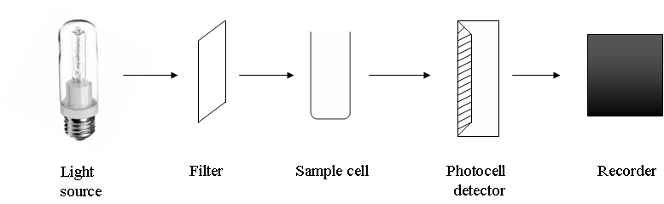

Photoelectric colorimeter consists of following parts
- Tungsten lamps as light source
- A filter which provides the desired wavelength range.
- A sample cell.
- A photocell detector.
Light from tungsten lamp, after passing through the filter is allowed to fall on the solution taken in
in the sample cell. First, a blank solution is taken in the sample cell and placed in the path of light beam. Its absorbance is measured and it is adjusted to zero. Then the analyte solution is placed in the path of light and its absorbance is measured.

Applications:
Colorimetry is used in the estimation of copper.
Principle: Solution containing Cu²⁺ ions is treated with NH₃ solution. Cu⁺² ions react with NH₃ to form a deep blue coloured cuprammonium complex ion.
Procedure: Transfer 2,4,6,8 and 10 cm³ of given copper sulphate solution into different volumetric flask from a burette. Add 2.5 cm³ of ammonia to all the flasks and make up all the solutions upto the mark using distilled water. Stopper the flasks and shake well to get uniform concentration.
Prepare a blank solution by taking 2.5 cm³ of ammonia in another 25cm³ volumetric flask. Make up that solution also upto the mark with distilled water and shake well. To the given unknown solution also add 2.5 cm³ of ammonia and make it up to the mark, shake well. After ten minutes measure the absorbance of all solutions against blank at 620 nm using a photoelectric colorimeter. Note down the optical density of all the solutions and tabulate the readings. Draw a calibration curve by plotting a graph of absorbance against volume of copper sulphate taken. Using the calibration curve, find out the unknown volume of copper sulphate solution given and calculate the amount of copper present in it.
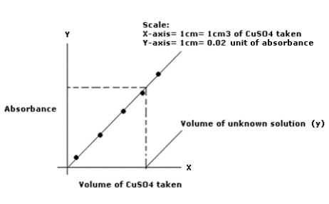
Calculation
1000 ml of 1M of CuSO₄ solution = 4.032 g of CuSO₄
1 ml of 1M of CuSO₄ solution = 4.032 x 10⁻³ g of CuSO₄
249 g of CuSO₄ contains 63.55 g of Cu
4.032 x 10⁻³ g of CuSO₄ =63.55 x4.032 x 10⁻³/249 g of Cu
1 ml of 1M of CuSO₄ solution =63.55 x4.032 x 10⁻³/249 g of Cu
Y g of CuSO₄ = Y x 63.55 x 4.032 x 10⁻³/249 g of Cu

Potentiometry
The procedure of using measurement of e.m.f to determine the concentration of ionic species in solution is referred to as potentiometry. The relation between electrode potential and metal ion concentration is given by the
Nernst equation.
It can be seen from the equation that the potential of an electrode E depends upon the concentration of the ion M^{n+} to which it is reversible.

Instrumentation:

Potentiometer consists of a reference electrode, an indicator electrode and a device for measuring the potential. The indicator electrode responds rapidly to the changes in the potential due to the concentration changes of the analyte.
A known volume of the analyte is taken in a beaker and its potential is determined by connecting the assembly to a potentiometer. The titrant is added in increments of 1 ml and the potential is measured each time. Close to the equivalence point, there is a sharp increase in the potential. The end point is determined by plotting change in potential against the volume of titrant.

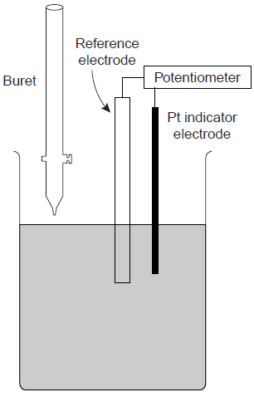

Applications:
1. Oxidation reduction titrations:
In red-ox titrations the indicator electrode is an inert metal such as platinum and reference electrode (Saturated calomel electrode). The potential of the electrode depends on the concentration of the substance being oxidized or reduced.
The advantage of following redox titrations potentiometrically is that it does not depend on the color change or redox indicators. In addition several analytes present in the same solution can be estimated by a single titrating
solution.
A typical example of a redox titration is that of Fe(II) against KMnO₄, or K₂Cr₂O₇ or Ce(IV) sulphate. The oxidizing agent is usually taken in the burrette.
POTENTIOMETRIC ESTIMATION OF Fe USING STANDARD K₂Cr₂O₇ SOLUTION

Principle: During the potentiometric titration, there is a sudden change in the value of potential at the equivalence point and it is measured using a platinum-calomel electrode assembly. The titration of Mohr’s salt solution with K₂Cr₂O₇ in the presence of H₂SO₄ is a redox titration. The presence of oxidized and reduced form of the same substance in a solution gives rise to the formation of an oxidation-reduction electrode, developing an electrode potential, which can be picked up by a platinum wire. Thus, when the titration is commenced, both Fe²⁺ and Fe³⁺ ions are present in the solution, developing an electrode potential which is picked up by a platinum wire.
As K₂Cr₂O₇ solution is added continuously, [Fe³⁺] goes on increasing and [Fe²⁺] goes on decreasing, gradually changing the potential. Near the end-point, the ratio [Fe³⁺] / [Fe²⁺] increases rapidly as [Fe²⁺] becomes very small, and tending to zero at the end-point. When Fe²⁺ is completely converted to Fe³⁺ by K₂Cr₂O_{7,} the electrode, Pt/ Fe³⁺ , Fe²⁺ ceases to exist. But the presence of slight excess of K₂Cr₂O₇ brings in existence of (Pt / Cr⁶⁺, Cr³⁺) electrode which is going to change.
Due to both the factors, increase in the value of [Fe³⁺] / [Fe²⁺] and change of electrode from Pt/ Fe³⁺ , Fe²⁺ to Pt/Cr⁶⁺, Cr³⁺ , there is a large change in potential at the end-point.

Procedure: Fill the burette with K₂Cr₂O₇ solution, wash the electrodes thoroughly with distilled water. Add two test-tubes of dilute sulphuric acid to the given FAS solution. Dip the electrode assembly into the given FAS solution. Note down the initial (for 0.0) potential value. Add K₂Cr₂O₇ in increments of 0.5 cm³ from the burette and measure the potential after each addition.
Plot a graph of against volume of K₂Cr₂O₇ ^{and} find the endpoint. Calculate the normality of FAS and determine the amount of FAS in the given solution.
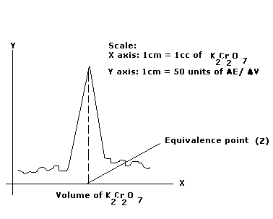
Calculation:
(N x V)_{FAS} = (N x V) _{K2Cr2O7}
N _{FAS} =
= $\frac{0.5 X Z}{25}$
N _{FAS} = ……… N
Amount of FAS present in 1000 cm³ of the solution
= N _{FAS} x eq. wt of FAS
= ………..x 392
= ……….. (a) g
392 g of FAS contains =55.85 g of Fe
a g of Fe contains = 55.85 x a/392
Result: Amount of Fe present in 1000 cm³ of the solution is …………. g.

Coductometry
Electrolyte solution conduct current by the migration of ions under the influence of an electric field. Like metallic conductor, they obey Ohm’s law,
E = IR
Ohm’s law states that the current ‘I’ flowing through a conductor is directly proportional to the applied potential, E and inversely proportional to the resistance R of the conductor.
The reciprocal of the resistance is called the conductance. The resistance of a homogeneous material of uniform cross section with an area of ‘a’ sq. cm. and length ‘1’ cm is given by
R = ρ.1/a
Where ρ is the specific resistance. The reciprocal of the specific resistance is termed the specific conductance, κ.
Specific conductance of an electrolyte solution is the conductance of the solution present between two parallel electrodes of 1 cm² area of cross section and 1 cm apart.
l/a is known as the cell constant and R is the resistance of the solution.
The specific conductance of an electrolyte solution at a given temperature depends on the number of ions present, size of the ions and mobility of the ions. On dilution of an electrolyte solution, its specific conductance decreases as the number of ions per ml decreases.
Conductance measurements are used to determine the equivalence point in acid-base titrations. There is a sudden change in conductance of the solution after the equivalence point. The equivalence point is determined graphically by plotting conductance against the titre values.
Instrumentation:
It consists of two platinum electrode each of unit area of cross section placed unit distance apart. The electrode are dipped in the electrolyte solution taken in a beaker. It is connected to a conductance measuring device. The titrant is added from a burette and the solution is stirred. The conductance is measured after the addition of the titrant at intervals of 1 ml.
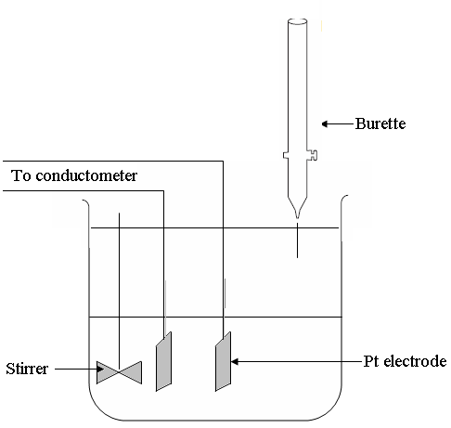

Applications:
1. Acid mixture with a strong base (HCl & CH3COOH v/s NaOH)
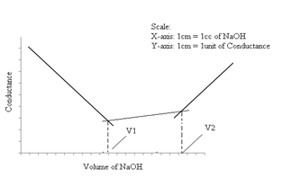
The conductance of the solution is maximum, before the addition of NaOH, the highly mobile H⁺ ions of the acid are replaced by less mobile Na⁺ ions in the beginning, and hence conductance decreases steeply. This trend continues till all the H⁺ ions of HCl are replaced i.e., the strong acid is neutralized. Continued addition of NaOH raises the conductance moderately, as the weak acid, CH₃COOH is converted into its salt, CH₃COONa. With the addition of NaOH the conductance increases slightly even though the highly mobile H⁺ ions are replaced by the less mobile Na⁺ ions. This is because the salt formed by the reaction is highly ionized. Also, further dissociation of weak acid takes place. The addition of NaOH, towards the end raises the conductance steeply due to the presence of free OH⁻ ions, of relatively higher mobility.

